Adaptive Air Pressure Regulation System
Design, Development, and Optimization of a Pressure-Controlled Solenoid System Using ESP32

1. Introduction
Maintaining a stable pressure difference between two environments is a common requirement in ventilation systems, enclosures, and controlled airflow applications. This project focuses on the design and implementation of an adaptive air pressure regulation system using an ESP32 microcontroller, dual pressure sensors, and a solenoid valve.
The system measures pressure inside and outside an enclosure, computes the differential pressure, and actuates a solenoid valve to correct deviations. Over multiple development iterations, the project evolved from basic pressure sensing into a fully networked, data-logged, and feedback-driven control system.
This document explains the step-by-step progression of the project, highlighting design decisions, challenges, improvements, and the final optimized solution.

2. System Overview
2.1 Hardware Components
- ESP32 microcontroller
- Two DPS310 digital pressure sensors
  - One measuring outside air pressure
  - One measuring inside air pressure
- Solenoid valve controlled via relay / driver
- Power supply and wiring
2.2 Software Stack
- Arduino framework for ESP32
- DPS310 sensor library
- ESPAsyncWebServer for web interface
- SPIFFS for file storage
- EEPROM for persistent configuration

3. Version 1 – Dual Pressure Sensing and Baseline Calibration
Objective
The first version aimed to validate pressure sensing hardware and ensure accurate differential pressure measurement using two DPS310 sensors.
Implementation
- Two DPS310 sensors were connected over I²C with different addresses.
- High-resolution pressure sampling was enabled for stable readings.
- A baseline calibration was performed at startup to account for sensor offsets.
- Pressure values and their difference were displayed on the serial monitor.
Outcome
This version confirmed:
- Reliable sensor communication
- Stable pressure readings
- Correct calculation of pressure difference
However, there was no actuator control or automation at this stage.

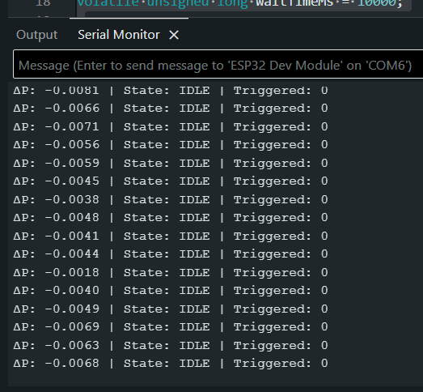
Serial Monitor output showing ΔP

4. Version 2 – Threshold-Based Relay Control
Objective
After validating sensing, Version 2 introduced basic automatic control by driving a relay based on pressure difference.
Key Changes
- A relay-controlled solenoid valve was added.
- A pressure threshold determined when the valve should toggle.
- A fixed toggle interval prevented rapid switching.
Observations
While the system reacted to pressure differences, it exhibited:
- Continuous relay toggling
- Pressure oscillations
- Mechanical stress on the solenoid
This version demonstrated that simple threshold logic was insufficient for stable control.

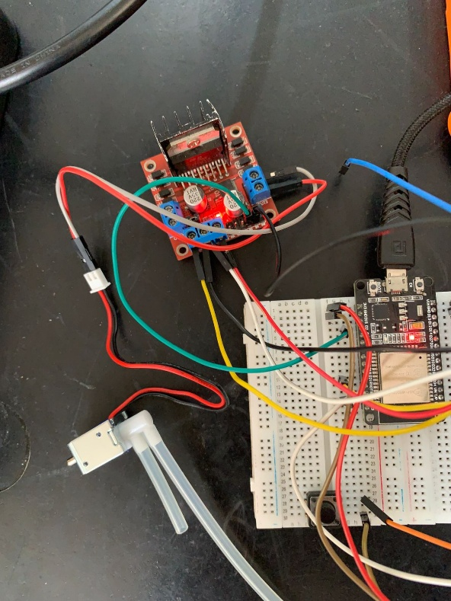
Motor Driver module and solenoid valve connection

5. Version 3 – Finite State Machine–Based Control
Objective
Version 3 focused on stability and deterministic behavior by replacing simple toggling logic with a finite state machine (FSM).
FSM Design
The solenoid control logic was structured into four states:
- IDLE
- OPEN_PULSE
- CLOSE_PULSE
- WAIT_PHASE
Each correction cycle consisted of:
- Two controlled valve pulses
- Fixed ON and OFF durations
- A long waiting phase to allow pressure stabilization
Improvements
- Eliminated relay chatter
- Reduced overshoot
- Improved system predictability
This version marked the first reliably stable control behavior.
6. Version 4 – Networked and Data-Logged Control System
Objective
The goal of Version 4 was to make the system observable, configurable, and analyzable.
Major Additions
- ESP32 SoftAP mode for standalone WiFi operation
- Web-based dashboard for real-time monitoring
- Live pressure graph using HTML canvas
- Runtime adjustment of delay between valve cycles
- Persistent storage of delay value using EEPROM
- CSV data logging using SPIFFS
Data Logging
The system logged one row per second containing:
- Time since boot
- Outside pressure
- Inside pressure
- Pressure difference
- Configured delay value
This enabled offline analysis and performance evaluation.

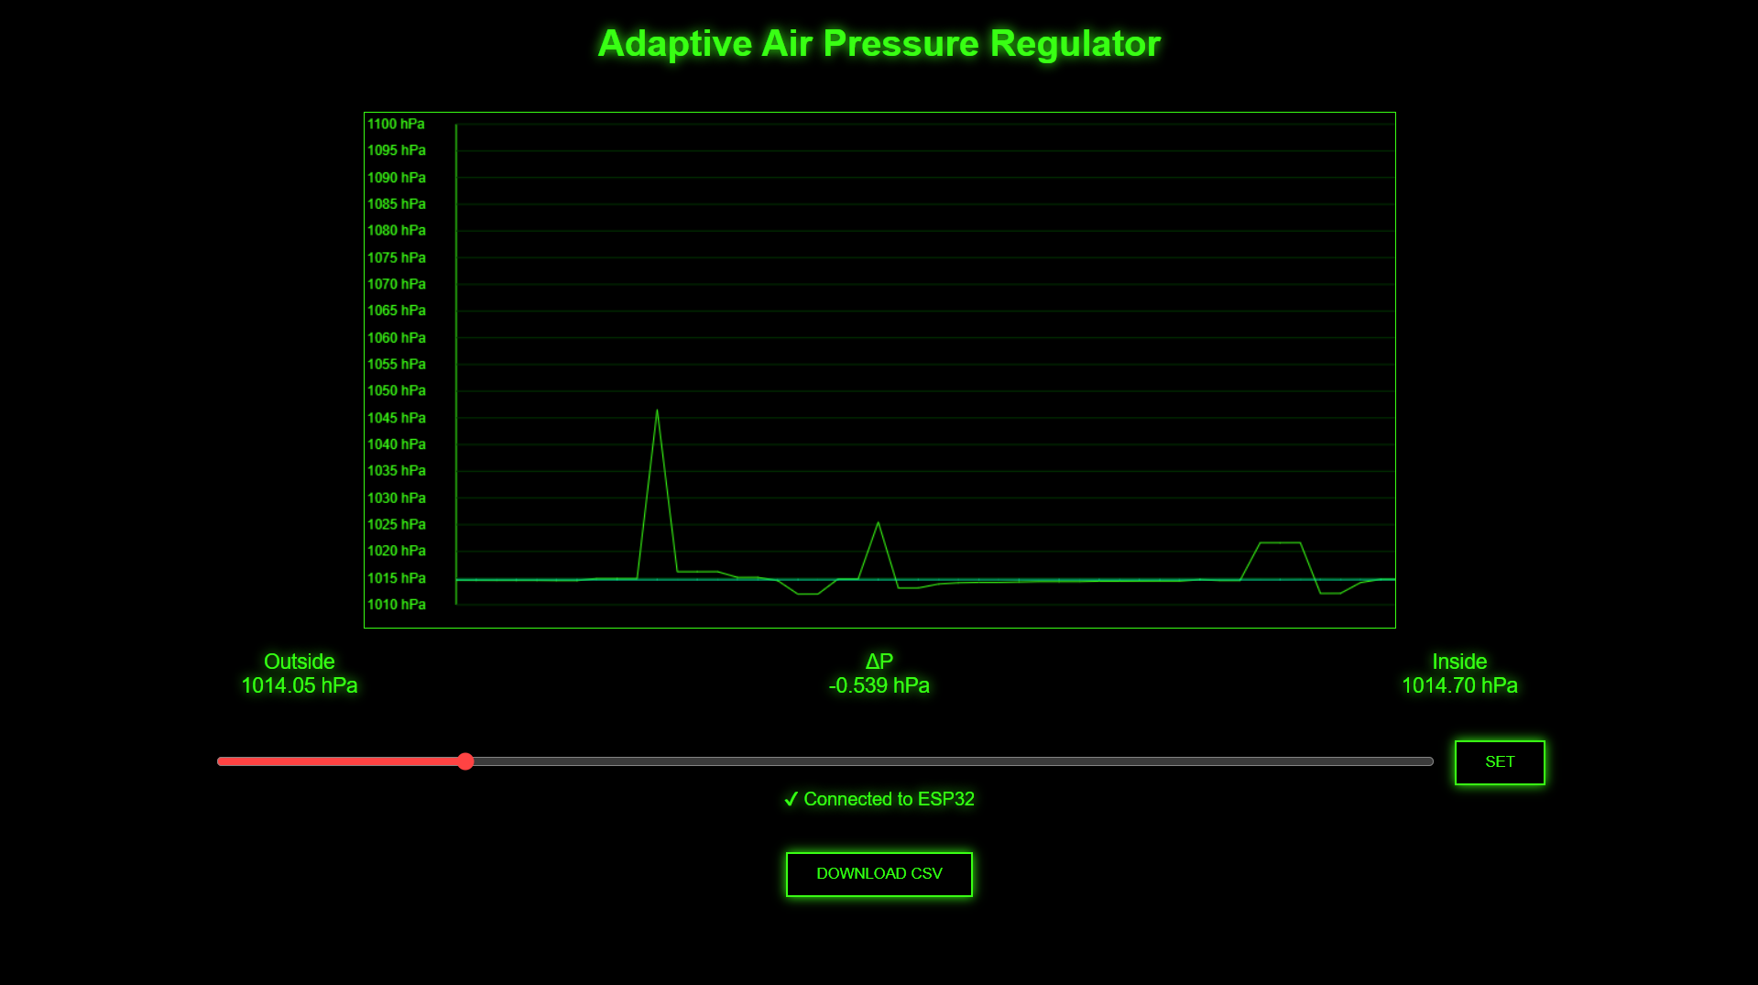
Web dashboard showing live graph and pressure values

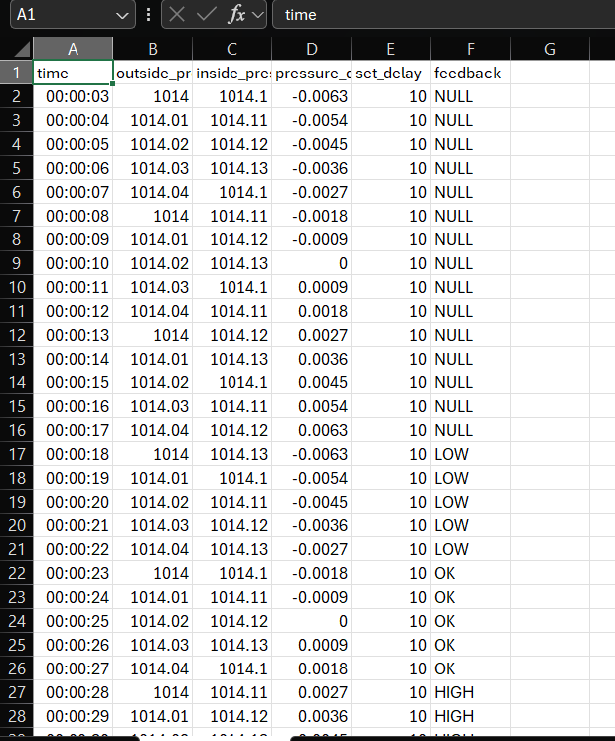
CSV file opened in Excel / Google Sheets

7. Version 5 – Feedback-Driven Final System
Objective
The final version introduced a human-in-the-loop feedback mechanism, allowing subjective system performance to be captured and analyzed.
Feedback System
After setting a delay value, the user could provide feedback via the web interface:
- LOW – Delay too short (aggressive response)
- OK – Delay optimal
- HIGH – Delay too long (slow response)
This feedback was:
- Stored in memory
- Logged alongside sensor data in the CSV file
- Initialized as "NULL" at boot to avoid empty entries
Final CSV Structure
time,outside_pressure,inside_pressure,pressure_difference,set_delay,feedback
Each dataset now contained both objective measurements and subjective evaluation, enabling optimization.

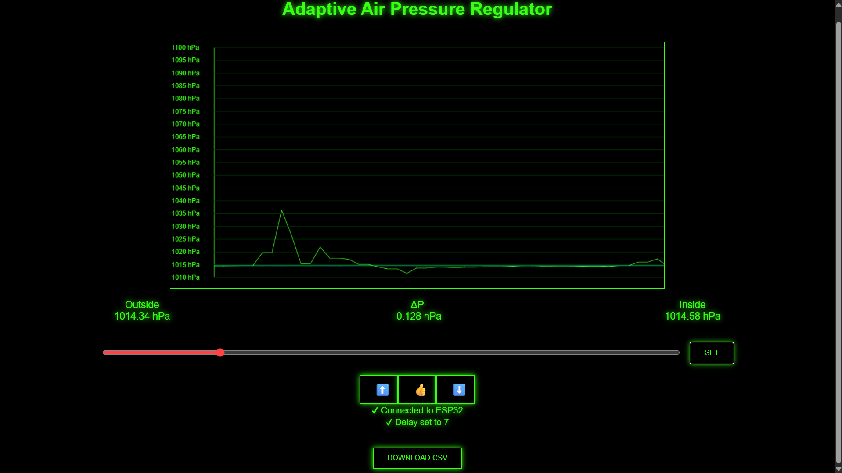
Web UI showing feedback buttons & Feedback confirmation message

8. Data-Driven Optimization
By analyzing CSV logs across multiple runs, it became possible to:
- Compare different delay values
- Correlate feedback with pressure stability
- Identify delay values most frequently rated as “OK”
This transformed the system into an experiment-driven controller, rather than a fixed-parameter design.

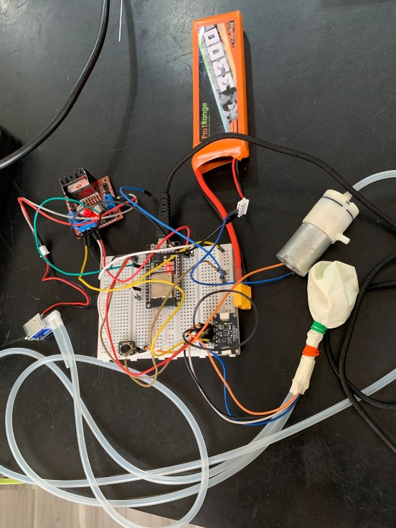
9. Final System Capabilities
The completed system demonstrates:
- Reliable differential pressure measurement
- Stable solenoid valve control
- Non-blocking real-time operation
- Web-based monitoring and configuration
- Persistent settings across power cycles
- Continuous data logging
- Human feedback integration
- Optimization readiness

10. Project Evolution Summary
Version | Key Achievement
Version 1 | Dual pressure sensing & baseline calibration
Version 2 | First closed-loop control attempt
Version 3 | Stable FSM-based valve control
Version 4 | Networked, configurable, logged system
Version 5 | Feedback-driven, optimization-ready system

11. Conclusion
This project successfully demonstrates the design and evolution of an adaptive air pressure regulation system. Starting from basic sensor validation, the system evolved into a fully featured, data-driven control platform.
By integrating embedded systems, web technologies, persistent storage, and human feedback, the final solution reflects strong engineering methodology and system-level thinking.
The approach and architecture developed in this project can be extended to:
- Industrial pressure control
- Environmental monitoring systems
- Smart ventilation solutions

12. Future Scope
Potential future improvements include:
- Automatic delay optimization algorithms
- Cloud-based data storage
- Mobile-friendly web interface
- Advanced control strategies (PID or adaptive control)

